Eyeconic-Cloths Shop Management System

Remove Cloths

Version <1.0>

Revision History

|  |  |  |  |
| --- | --- | --- | --- |
| **Date** | **Version** | **Description** | **Author** |
| <04/11/2019> | <1.0> | creating use case | Nguyễn Tuấn Anh |
|  |  |  |  |

Table of Contents

1. Remove Cloths 4

1.1 Brief Description 4

2. Flow of Events 4

2.1 Basic Flow 4

2.2 Exception 4

2.2.1 Remove Cloths 4

2.2.2 Confirming editing the brand 5

3. Special Requirements 5

4. Preconditions 5

4.1 Admin must be logged in 5

5. Postconditions 5

6. Extension Points 5

Use-Case Specification: Remove Cloths

# Remove Cloths

## Brief Description

This use case defines the step of delete exist Cloths from the database.

Cloths are removed by the admin.

# 2. Flow of Events

## 2.1 Basic Flow

The system administration selects the Cloths data to remove. The administrator deletes the Cloths data from the website. The system displays the updated management parameter value and logs the change

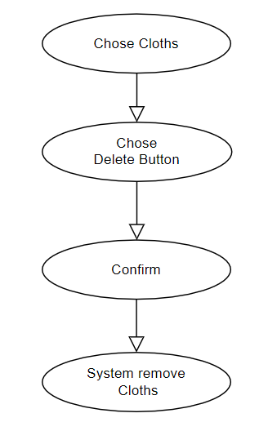

***Basic flow of Removing Cloths***

Step 1: Choose the Cloths you want to remove

Step 2: Click remove button

A modal view shows up with content “Are you sure want to remove this item?”

and two button “Yes” and “No”

Step 3: Confirming adding the Cloths by clicking the “Yes” button.

Step 4: Cloths are removed from database and no longer appeared on the screen.

## 2.2 Exception

### 2.2.1 Remove Cloths

The remove button cannot be clicked or isn’t appeared on the screen

### 2.2.2 Confirming editing the brand

The “Yes” button is clicked but the brand are not removed

# 3. Special Requirements

No Special Requirements

# 4. Preconditions

## 4.1 Admin must be logged in

User must already login as the administrator of the website

# 5. Postconditions

All others product can be shown and purchases as normal.

Deleted Cloths cannot be seen on the screen or database.

# 6. Extension Points

Administrator check the website and the system to ensure that the Cloths is completely removed.